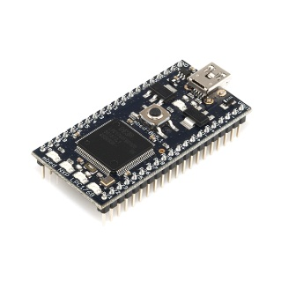
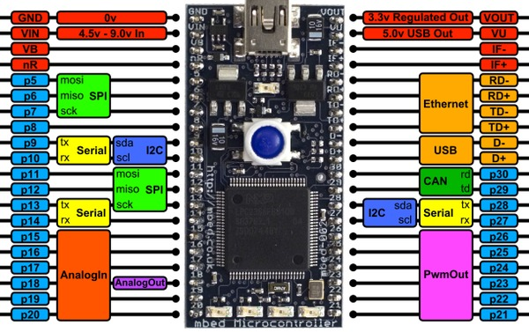
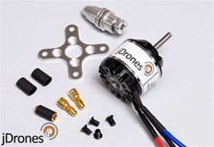
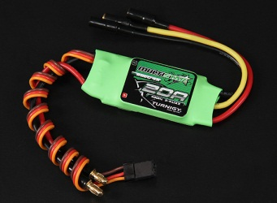
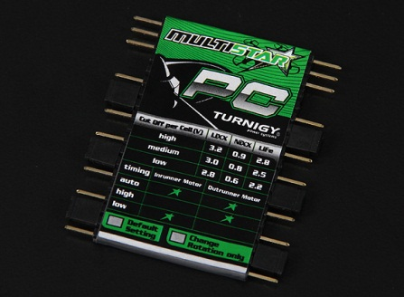
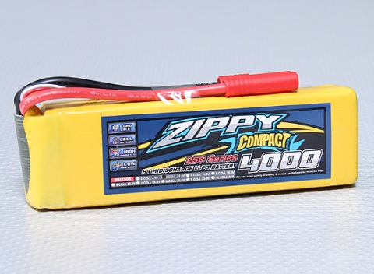
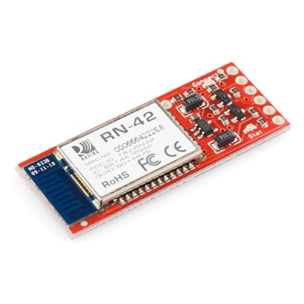
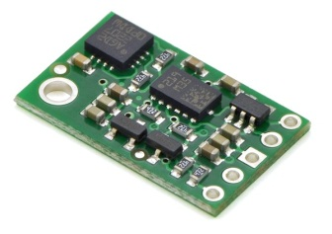
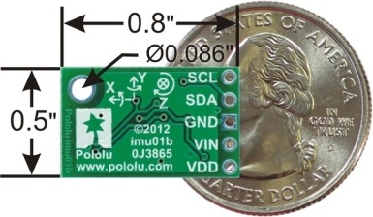
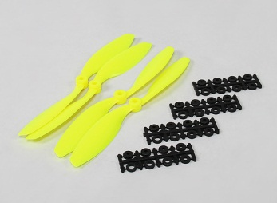
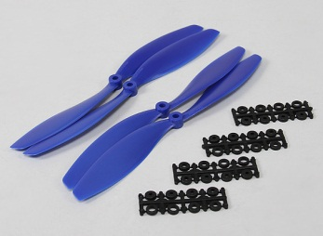
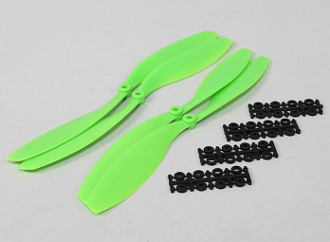
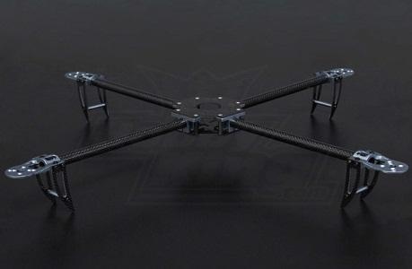
Quadcopter Component List – George Allen, Mark Alitawi & Cory Gordinier

- Microcontroller
  - Description: ArduPilot Mega 2560
  - Manufacture: JDrones
  - Supplier: JDrones
  - Supplier Link:http://store.jdrones.com/ArduPIlotMega_p/jdapm256cpu.htm
  - List Price: $48.50
  - Image:

- Brushless Motor
  - Description: Light weight, low kv motor used to drive propellers
  - Manufacture: jDrones AC2830-358
  - Link: http://store.jdrones.com/default.asp
  - Supplier: jDrones
  - Supplier Link: http://store.jdrones.com/AC2830_358_Motors_p/ac2830358.htm
  - List Price: $18.00 x4
  - Image:
- Electronic Speed Controller
  - Description: Electronic Speed controller using PWM to control a brushless motor
  - Manufacture: Turnigy 20Amp ESC
  - Supplier: HobbyKing
  - Supplier Link: http://goo.gl/LlSHd
  - List Price: $9.00 x4
  - Image:
- ESC Programming Card
  - Description: Card for programming each ESC individually
  - Manufacture: Turnigy Mulistar ESC Programming Card
  - Supplier: Hobbyking
  - Supplier Link: http://goo.gl/KdGlT
  - List Price: $4.00
  - Image:

- Battery
  - Description: Light weight 4000mAh battery used to power electronics and motors
  - Manufacture: Zippy Compact 4000mAh 3s 25C
  - Supplier: HobbyKing
  - Supplier Link: http://goo.gl/ZMNji
  - List Price: $26.00
  - Image:
- Bluetooth
  - Description: Bluetooth module for communication between MCU and Playstation controller
  - Supplier: Pololu
  - Supplier Link: http://www.pololu.com/catalog/product/2194
  - List Price: $40.00
  - Image:

- Inertial Measurement Unit
  - Description: 3-axis Gryo, 3-axis Accelerometer & 3-axis Magnetometer in a small package
  - Manufacture: Pololu minIMU-9 v2
  - Supplier: Pololu
  - Supplier Link: http://www.pololu.com/catalog/product/1268
  - List Price: $50.00
  - Image:
- Pressure & Temp Sensor
  - Description: Pressure and Temp sensor used for altitude
  - Manufacture: DIY Drones BMP085
  - Supplier: DIY Drones
  - Supplier Link: http://store.diydrones.com/product_p/br-0011-01.htm
  - List Price: $25.00
  - Image:

- Propellers
  - Description: Four propellers, two spin clockwise and two spin counter clockwise
  - Supplier: HobbyKing
  - Supplier Link:
    - http://goo.gl/yOHK2 8” prop
    - http://goo.gl/ZdjKL 10” prop
    - http://goo.gl/XrloS 12” prop
  - List Price:
    - $3.00 8” prop
    - $3.00 10” prop
    - $4.00 12” prop
  - Image:
- Frame
  - Description: Carbon Fiber & Aluminum frame and tubular arms to hold wiring.
  - Manufacture: Turnigy Talon Quadcopter (V2.0)
  - Supplier: HobbyKing
  - Supplier Link: http://goo.gl/VUsha
  - List Price: $50.00
  - Image:

